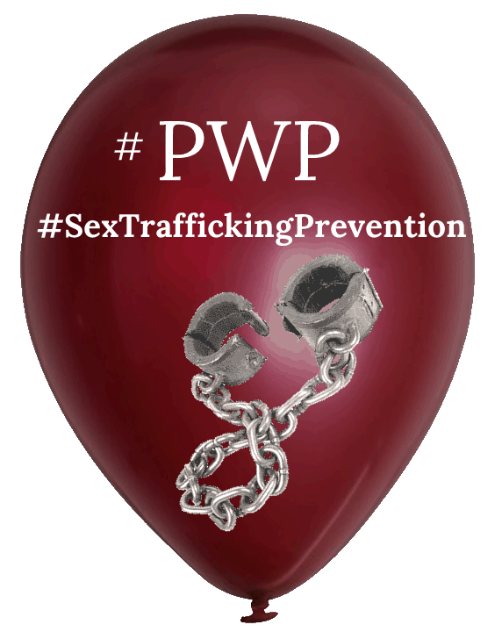
Sex Trafficking Prevention Workshop Questionnaire

Tonight’s presentation will evoke these emotions.
Write down what it was that caused each of these emotions
while going through the presentation.
Concern,
Fear
Anger
Outrage
Enjoyment
Compassion
Acceptance
Love
Hope

Question 1:
What are the 3 main reasons that most people are trafficked?

1___________________________________________

2___________________________________________

3___________________________________________

Question 2:
What two ‘other’ important points must we remember to ensure we are doing all we c an to prevent our loved ones from being abused or trafficked?

1._____________________________________________________________

2. _____________________________________________________________

Question3:

_______% of survivors have been trafficked by someone they know

Question 4:
List the 5 stages of Trafficking.

- ______________________________

- ______________________________

- _______________________________

- _______________________________

- _______________________________

Question 5:
What two strategies are most commonly used by traffickers to get their victims.

- ____________________________________

- ____________________________________

Question 6:
List at least 5 Red Flags:

- __________________________________________

- __________________________________________

- __________________________________________

- __________________________________________

- __________________________________________

Question 7:
List the 5 Highest Vulnerabilities that would make someone an easy target for a trafficker.

- ___________________________________________

- ___________________________________________

- ___________________________________________

- ___________________________________________

- ___________________________________________

Question 8:
Four other risk factors that might be more likely to happen those who come from good homes.

- ____________________________________________

- ____________________________________________

- ____________________________________________

- ____________________________________________

Question 9:
What is the definition of Vulnerable?

Question 10:
List 5 ways you can think of that will allow you to have more quality time with your loved ones which will help you see when and if they have any vulnerabilities.

- _____________________________________________________________

- _____________________________________________________________

- _____________________________________________________________

- _____________________________________________________________

- _____________________________________________________________

Question 11:
List the 4 things that must be present in order to give CONSENT.
- ___________________________________________________________

- __________________________________________________________

- ___________________________________________________________

- ___________________________________________________________

Question 12:
What ‘parts’ of consent were you not aware of?
1. __________________________________________
2. __________________________________________
3. __________________________________________

Question 13:
List 3 ways you can teach consent to a toddlers.
1. ___________________________________________
2. ___________________________________________
3. ___________________________________________

Question 14:
List 3 ways you can teach consent to a teen.
1. ____________________________________________

2. ____________________________________________

3. ____________________________________________

Question 15:
What one thing did we suggest that would ensure that your child has extra lifelines he/she can reach out to if they need to talk to an adult?

____________________________________________________________

Question 16:
What are the 4 call to actions you need to start doing if you have not done so already.

- ________________________________________________________________

- ________________________________________________________________

- ________________________________________________________________

- __________________________________________________________________

List of people you trust List of people your child trust.

1. 1.

2. 2.

3. 3.

4. 4.

5. 5.

6. 6.

If you have any questions or wanted to discuss this workshop, please contact us at parentwithpurpose.ca@gmail.com.

